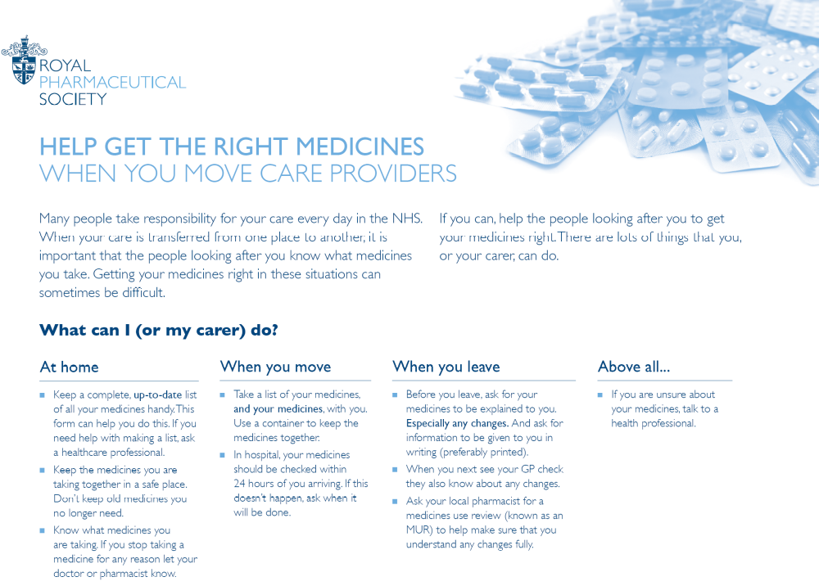


Always take this list with you when you move between care providers

Patient’s name:

NHS number (where known):

My current medicines

Please list all medicines including inhalers, eye/ear drops, patches, injections, and alternative/herbal medicines

Medicine | Presentation (e.g. tablet, liquid, patch) | Dose | Frequency  (How often I take my medicines e.g. daily) | Additional information  (e.g. What I take this medicine for)
Notes about my medicines
Medicines I cannot take
Name of medicine | Reason

You can download further copies of this form at www.rpharms.com/toc

